PSYC2007: Behaviour Change

**Assessment 3: Project Proposal**

**Student name**: _____Alan Love__________________________

**Student number**: ________23702790_____________________

**Word count** (not including cover page, references,

tables and figures, legends, or appendices): ____2049________

**Student declaration**

I have read and understand the Rules Relating to Awards ([*Rule 3 Section 18 – Academic Misconduct Including Plagiarism*](http://policies.scu.edu.au/view.current.php?id=00140#s18)) as contained in the SCU Policy Library. I understand the penalties that apply for plagiarism and collusion and agree to be bound by these rules. The work I am submitting electronically is entirely my own work, unless otherwise indicated.

|  |  |
| --- | --- |
| Signed: | Alan Love |
|  | (Please type your name) |
| Date: | 22/09/2022 |

**Start your written report on next page!**

**Program for decreasing sedentary behaviour among office workers**

This paper proposes a program for reducing sitting time among office workers.

**Background**

Sedentary behaviour can be described as any individual exhibiting postures like sitting, lying, or reclining for extended periods, which limit their energy expenditure (<1.5 metabolic equivalents) (Ojo et al., 2022). Sedentary behaviour is acknowledged as a unique behaviour increasingly prevalent among people who spend their time travelling, watching television, browsing the internet, and working on computers (O’Connell et al., 2015). Since the rise of technological innovations like computers and labour-saving devices, society has drastically modernised, now relying upon electronic devices in the workplace, ultimately altering occupational environments in recent decades (Ojo et al., 2019). For instance, Occupation physical activity trends in the USA over the past 50 years have shown a progressive shift from intense physical occupations to roles that require prolonged sitting time (Dunstan et al., 2013). In particular, office workers exhibit high amounts of sedentary behaviour inside and outside the office (Munir et al., 2018). For instance, an observational study using hip-worn accelerometers reported that 75% of total work time was sedentary among Australian office employees. Additionally, it was specified that approximately 22-52% of sedentary time was accumulated in 30 min and longer uninterrupted bouts (Dunstan et al., 2013).

Furthermore, long periods of sedentary behaviour can be linked to alarming health consequences. Potential hazards were initially highlighted around the 17th century by a physician named Ramazzini, who reported that workers sitting for long periods exhibited harmful health consequences. Additionally, researchers in the 1950s reported higher incidences of coronary heart disease among bus drivers and mail sorters who required more sedentary behaviour compared to bus conductors and post-delivery workers who were required to stand and ambulate (Dunstan et al., 2013). Presently, high levels of sedentary behaviour with prolonged sitting sessions can be related to overweight risks like obesity, several types of cancer, type two diabetes, cardiovascular disease, mental health problems such as anxiety and depression and premature death (O’Connell et al., 2015; Ojo et al., 2022). Thus, the negative relationships between severe health consequences and prolonged sedentary behaviour illustrate crucial public health concerns prompting requests for interventions for populations in high-risk occupational settings like office workspaces (Dunstan et al., 2013).

Moreover, interventions for prolonged sedentary behaviour have primarily focused on ergonomics by reducing musculoskeletal complaints and sitting time (Dunstan et al., 2013). Strategies for interventions have included: information provision, counselling, policy change (Munir et al., 2018), increased quantity of breaks from inactivity, frequent postural changes, and the implementation of sit-stand workstations (SSW), which modify ergonomic workspaces (Dunstan et al., 2013). Additionally, workplace interventions for reducing sedentary behaviour have been discovered to add metabolic benefits, reduce musculoskeletal complaints, improve health perceptions and reduce fatigue (O’Connell et al., 2015). Moreover, it is recommended that desk-based workers aim for 2-4 hours of standing and light activity each day (Ojo et al., 2022). A review of interventions found that SSWs led to the largest reductions in sitting from 30 minutes to 2 hours per day (O’Connell et al., 2015). However, SSWs alone may fail to achieve the recommended standing time (Dewitt et al., 2019). Thus, combining SSWs with several other strategies across different levels of intervention to account for individual and environmental factors is the most beneficial approach for reducing workplace sitting time (Stephens et al., 2018).

Furthermore, the behaviour change wheel (BCW) theoretical framework is recommended for guiding a systematic process to develop an intervention that also incorporates the target audience’s needs. Since organisation populations and settings are diverse from one another, involving employee experiences and perceptions in the development of interventions for reducing prolonged sitting bouts can ensure their needs are met, ultimately enhancing employee adherence and productivity (Ojo et al., 2022). The BCW consists of three layers. The first layer or core comprises three conditions that address the sources of behaviour targeted for intervention. The next layer consists of nine intervention functions chosen to address deficits in one or more of the three conditions. The outermost layer comprises seven types of policy for which one is put forth to deliver the intervention functions (see Figure 1). The BCW offers a three-stage step-by-step process for designing behaviour change interventions (see Figure 2) (Michie et al., 2014). Thus, this essay will deliver a proposed intervention for reducing sedentary behaviour in an office environment under the guidance of the BCW framework.

**Figure 1**

*The behaviour change wheel*

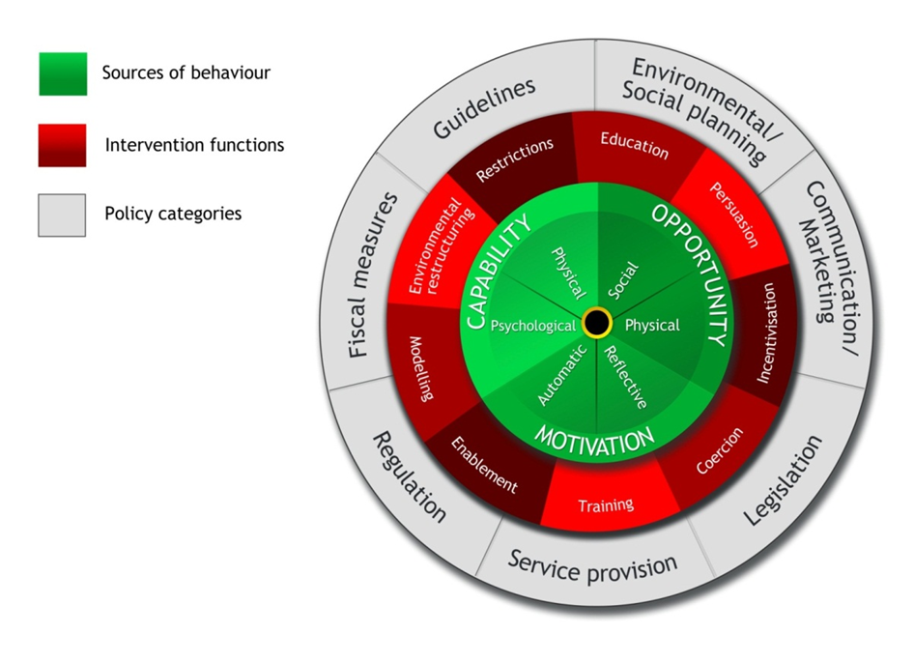

(Michie et al., 2014).

**Figure 2**

*Step-by-step method for designing behaviour change interventions*

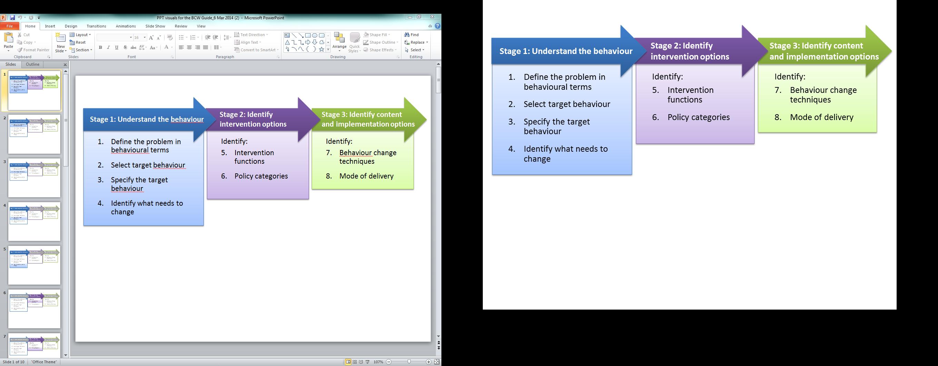

(Michie et al., 2014).

**Methodology**

The identified problem is increased bouts of sedentary behaviour associated with adverse health consequences. Next, select and specify the target behaviour, which is reduced sitting time within an office environment following recommendations of getting a minimum of 2-4 hours per working day (Ojo et al., 2022). Additionally, research suggests two target behaviours for intervention development: triggers to split up sitting time and strategies to promote regular standing time (Munir et al., 2018).

Furthermore, step four involves conducting focus groups or interviews with employees using the BCW as a guide to understand changes needed within the workplace, ensuring that future interventions for target behaviours are employee-centred and cocreated (Ojo et al., 2019). For example, Munir et al. (2018) applied readiness to change questionnaires prior to focus groups and found that participants were vaguely aware of what sedentary behaviour meant and associated health consequences. Also, participants knew about high levels of sedentary behaviour in the workplace but lacked the motivation to rectify it. Moreover, participants were encouraged to discuss strategies to reduce sitting time guided by the three core conditions within the BCW (see Figure 1). Firstly, Capability underlined how employees were absorbed by their work and unable to remember standing, indicating that prompts to encourage regular standing are essential. Also, Opportunity focused on environmental context and agreed that SSW was crucial. However, participants emphasised that collective social support and advice would help motivate one another to achieve targeted behaviours. Lastly, motivation highlighted how automatic desires, habits, and conscious planning were crucial for behaviour change. Participants felt that it would be less embarrassing if everyone was involved in breaking up their sitting time and found that making plans was beneficial, making it highly likely for participants to include ambulating and standing. Also, all participants agreed on understanding the risks associated with sedentary behaviour, eventually requesting education to reduce it further (Munir et al., 2018).

Moreover, stage two utilises the APEASE criteria (affordability, practicality, effectiveness and cost-effectiveness, acceptability, side-effects/safety, and equity), which helps identify relevant intervention functions and policy categories based on the findings from focus groups (Munir et al., 2018). For example, Ojo et al. (2022) specify five intervention functions appropriate for reducing sedentary behaviour within an office environment: education, enablement, training, persuasion, and environmental restructuring, in addition to three policy groups: communication/marketing, guidelines and environment and social planning.

Furthermore, stage three instructs using the APEASE criteria to select the most appropriate behaviour change techniques (considered active components when designing an intervention) for the intervention functions (Munir et al., 2018). As indicated by several studies, the primary strategy for achieving the target behaviour will be altering the environment by implementing SSWs and providing training on how to operate them effectively (O’Connell et al., 2015; Ojo et al., 2022; Munir et al., 2018). Also, prompting employees with cues such as email reminders and timers (stopwatch) to stand up, sit less and move more (Ojo et al., 2022). Information about the health consequences of sedentary behaviour and the benefits of breaking up sitting time will be applied through educational and motivational discussions, leaflets, and wall posters. Clustering employees into groups of 4 will create a social support environment that assists with regular standing. For instance, taking cues from regularly standing co-workers and encouraging others to reduce sitting time by self-modelling the behaviour. Also, to support behaviour change, each employee will be given a diary and information on how to set goals and plan how to achieve them. Lastly, sitting, standing, and movement feedback from activPAL3 will be given to employees regularly (Munir et al., 2018).

**Deliverables**

Primarily to measure the target behaviour participating employees will be equipped with a reliable and valid device called the activPAL3. This continuous monitor precisely records the beginning and end of each bout of sitting, standing, lying, and stepping at various speeds (Dunstan et al., 2013). The activPAL3 is a portable, lightweight device secured around the thigh section and must always be worn during working hours to be considered valid. Additionally, employees’ activPAL3 data will be analysed following the recommended guidelines for standing and stepping at work (2-4 hours) (Ojo et al., 2022). Thus, the activPAL3 is crucial for measuring the targeted behaviour.

Furthermore, since employees are required to meet deadlines, work outcomes such as presenteeism, absenteeism, and productivity will be measured using self-report questionnaires and the organisation’s internal human resources. For example, the health and work questionnaire will assess work performance, such as the amount and quality of work completed, meeting targets, error frequencies, taking responsibility, creativity and overall performance and dependability. Also, presenteeism and absenteeism will be assessed using the work limitations questionnaire, which evaluates occurrences in difficulties surrounding specific tasks (Dunstan et al., 2013). Measuring work outcomes can be beneficial for assuring managers or senior executives that implemented strategies do not negatively affect productivity levels.

Moreover, to assess whether the applied interventions are acceptable, employees will undergo semi-structured interviews six months post-intervention to discuss what aspects of the intervention worked for them. This data can be analysed with thematic analyses and again using the APEASE criteria for deductive reasoning (Ojo et al., 2022). For instance, Dewitt et al. (2019) study conducted semi-structured interviews post-intervention and found that participants perceived the intervention strategies as beneficial. Firstly, participants were quite shocked when they realised how much time they were sitting after receiving activPAL3 feedback, ultimately raising awareness. Secondly, participants reported increased standing time mainly due to SSW, which encouraged additional movement, like moving to another part of the office since they were already standing. Thirdly, participants felt increased comfortability being approached by others whilst standing at the SSW, creating equitable relationships since being at the same eye-to-eye level. However, participants found it challenging to conduct specific jobs while standing at the SSW, such as paper-based tasks. Participants also reported psychological difficulty raising the SSW for short-standing bouts and, if feeling tired, further limited motivation (Dewitt et al., 2019).

Consequently, this program is primarily designed to benefit people working in desk-based environments regardless of title. The first and most crucial benefit is health improvements. As previously discussed, sedentary behaviour can have alarming health consequences, and increasing standing and movement will reduce associated health risks. For instance, in Dewitt et al. (2019) study, participants reported musculoskeletal benefits from increased standing, such as improvements in posture, strength, and balance, in addition to reductions in pain. Additionally, employees can benefit from improved well-being and work satisfaction, having a positive outlook on their health, breaking up the mundane and habitual tasks of a traditional seated workstation and stronger interactions with colleagues, ultimately forging relationships (Rollo & Prapavessis, 2021). Again Dewitt et al. (2019) found their intervention instilled a sit less, move more attitude characterised by increased awareness within some participants who extended opportunities for sitting less outside of work hours like standing on public transport.

Furthermore, the organisation can benefit from investing in this program. Employers know that healthy and happy employees will be more engaged within the workplace, optimising productivity (Morris et al., 2018). Employers that implement strategies that promote mobile behaviour throughout the workday can improve their employees’ subjective vitality and psychological well-being since research shows that work satisfaction and perceived employer care are vital for work productivity and organisational growth (Patel et al., 2022). For example, in Dewitt et al. (2019) study, participants who stood whilst working felt enhanced attentiveness, ultimately increasing their productivity. Thus, employers caring for employees can have significant benefits like increased productivity and organisational growth.

**Final Statements**

Increased bouts of sedentary behaviour are related to several health risks. Thus, reducing it is vital for office workers’ longevity. As presented in this project proposal, organisations can sometimes access valid and reliable interventions that promote sitting less and moving more. However, some organisations will find that they need to design interventions for specific circumstances since populations and settings are heterogeneous. Therefore, by using the BCW theoretical framework, organisations can systematically develop relevant interventions to bring about change.

References

Dewitt, S., Hall, J., Smith, L., Buckley, J. P., Biddle, S. J. H., Mansfield, L., & Gardner, B. (2019). Office workers’ experiences of attempts to reduce sitting-time: an exploratory, mixed-methods uncontrolled intervention pilot study. *BMC Public Health, 19*(1), 819. <https://doi.org/10.1186/s12889-019-7196-0>

Dunstan, D. W., Wiesner, G., Eakin, E. G., Neuhaus, M., Owen, N., LaMontagne, A. D., Moodie, M., Winkler, E. A. H., Fjeldsoe, B. S., Lawler, S., & Healy, G. N. (2013). Reducing office workers’ sitting time: Rationale and study design for the Stand Up Victoria cluster randomized trial. *BMC Public Health, 13*(1), 1057. <https://doi.org/10.1186/1471-2458-13-1057>

Michie, S., Atkins, L., & West, R. (2014). *The behaviour change wheel: A guide to designing interventions.* Silverback.

Morris, A., Murphy, R., Shepherd, S., & Graves, L. (2018). Multi-stakeholder perspectives of factors that influence contact centre call agents’ workplace physical activity and sedentary behaviour. *International Journal of Environmental Research and Public Health, 15*(7), 1484. <https://www.mdpi.com/1660-4601/15/7/1484>

Munir, F., Biddle, S. J. H., Davies, M. J., Dunstan, D., Esliger, D., Gray, L. J., Jackson, B. R., O’Connell, S. E., Yates, T., & Edwardson, C. L. (2018). Stand More AT Work (SMArT Work): Using the behaviour change wheel to develop an intervention to reduce sitting time in the workplace. *BMC Public Health, 18*(1), 319. <https://doi.org/10.1186/s12889-018-5187-1>

O’Connell, S. E., Jackson, B. R., Edwardson, C. L., Yates, T., Biddle, S. J. H., Davies, M. J., Dunstan, D., Esliger, D., Gray, L., Miller, P., & Munir, F. (2015). Providing NHS staff with height-adjustable workstations and behaviour change strategies to reduce workplace sitting time: protocol for the Stand More AT (SMArT) Work cluster randomised controlled trial. *BMC Public Health, 15(*1), 1219. <https://doi.org/10.1186/s12889-015-2532-5>

Ojo, S. O., Bailey, D. P., Brierley, M. L., Hewson, D. J., & Chater, A. M. (2019). Breaking barriers: Using the behavior change wheel to develop a tailored intervention to overcome workplace inhibitors to breaking up sitting time. *BMC Public Health, 19*(1), 1126. <https://doi.org/10.1186/s12889-019-7468-8>

Ojo, S. O., Bailey, D. P., Chater, A. M., & Hewson, D. J. (2022). Workplace intervention for reducing sitting time in sedentary workers: Protocol for a pilot study using the behavior change wheel. *Frontiers in Public Health, 10*. <https://doi.org/10.3389/fpubh.2022.832374>

Patel, A. K., Banga, C., & Chandrasekaran, B. (2022). Effect of an education-based workplace intervention (move in office with education) on sedentary behaviour and well-being in desk-based workers: a cluster randomized controlled trial. *International Journal of Occupational Safety and Ergonomics, 28*(3), 1655-1663. <https://doi.org/10.1080/10803548.2021.1916221>

Rollo, S., & Prapavessis, H. (2021). A combined health action process approach and mHealth intervention to reduce workplace sitting time in office-working adults: A secondary analysis examining health-related quality of life and work performance outcomes. *Psychology & Health, 36*(10), 1200-1216. <https://doi.org/10.1080/08870446.2020.1838522>

Stephens, S. K., Eakin, E. G., Clark, B. K., Winkler, E. A. H., Owen, N., LaMontagne, A. D., Moodie, M., Lawler, S. P., Dunstan, D. W., & Healy, G. N. (2018). What strategies do desk-based workers choose to reduce sitting time and how well do they work? Findings from a cluster randomised controlled trial. International *Journal of Behavioral Nutrition and Physical Activity, 15*(1), 98. <https://doi.org/10.1186/s12966-018-0731-z>

Although rt-fMRI-nfb has many potential benefits, it is a complex process that can reduce the success rate of participants. Studies have shown that only 50-75% of subjects are successful in modifying brain activity in the desired direction, which suggests that the technique is not effective for everyone. Additionally, insufficient statistical power to identify significant transfer or group effects is a significant issue in the existing literature. To overcome this, studies should include at least 101 participants per group for a simple 2 (pre/post) × 2 (neurofeedback/control) design.

The placebo effect is also a concern in rt-fMRI-nfb studies, since some participants may show neural regulation in the same regions of the neurofeedback ROIs simply because they believe they are receiving honest feedback. To address this, double-blind placebo-controlled trials are essential. Finally, follow-up assessments are necessary to demonstrate that rt-fMRI-nfb has benefits beyond its ability to regulate brain activity in the short term.